Percussion Audition Protocol - 2015
Nova Scotia Junior Wind Ensemble

If submitting a recorded audition please record an audio file (mp3 or another standard file format) as an attachment and send it to Anthony MacPherson at Anthony@nsjwe.ca. You may also burn your audition to a disc and mail along with your application form to Anthony MacPherson.
You may send your audio file as one continuous audio file or you may save each scale and piece as their own audio file. In either option please name your files with your name and a description.
- i.e. bethgillis_fullaudition.mp3 OR bethgillis_GMajorScale.mp3

If your recording is one continuous file:
- At the beginning please state your full name, age, school you will attend next year.
- Before each scale please indicate which one you are performing.
- Before each piece please indicate the title and composer of each piece. If your pieces come from a method book please indicate which method book it is from or if it is the required excerpt.
- You will not be required to perform sight reading.

You must send all three parts of the following recorded items plus the audition form for consideration for entrance into the group. If sending a recording please include your $10 audition fee with your application but separate from your ensemble fees. If attending a live audition please prepare all three parts of the following items as well.
Part #1 - Scales Please play four scales on a mallet instrument: (a) Bb concert chromatic scale (b) B-flat concert scale, 2 octaves if possible (c) F concert scale, 2 octaves if possible (d) Ab concert scale, 2 octaves if possible
Part #2 - Own Choice Playing Sample This can be any measures of a solo, etude, or excerpt from your band music that you can play well. Please count any rests shorter than 2 measures; otherwise, skip ahead to your next entrance after a measure or two.

Part #3 – Required Excerpt:
Mallets
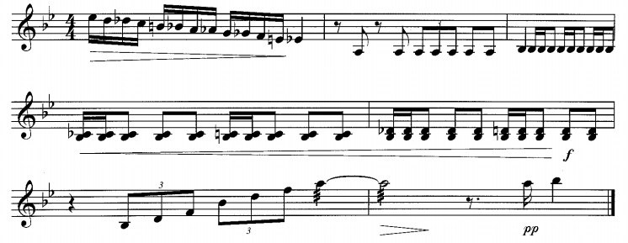
Timpani
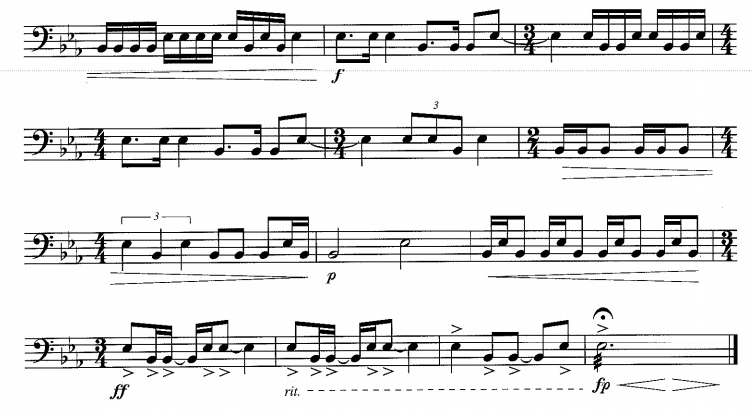

Snare
